Tab 1

CRM/Marketing Assistant Agent
### Multi-Agent Workflow for Lead Research, CRM Updates, Email Automation & Content Scheduling
**Kaggle x Google Agents Intensive – Capstone Project**
**By: Leah Oduor ”Leah The Digital VA”**

---

## Overview
This project is a **multi-agent AI system** designed to automate common CRM and marketing tasks for small businesses and solopreneurs. It performs:

- Lead research
- CRM updating
- Follow-up email generation
- Content scheduling

The system is built as a **4-agent sequential workflow**, orchestrated by a central coordinator.
This mirrors an enterprise pipeline and demonstrates core Agent Development Kit (ADK) concepts:
tools, agents, context passing, observability, and model integration.

This repository contains:
- Full Kaggle notebook
- Architecture diagram
- Documentation of all agents
- Simulated tools for safe, reproducible execution

---

## Problem Statement
Small businesses struggle to manage CRM tasks effectively. Lead follow-ups, CRM updates, writing emails, and planning content require time they don’t have.
This leads to:

- Missed opportunities
- Slow client response times
- Poor marketing consistency
- Lost revenue

This project automates these tasks using **AI agents that work together.**

---

## Why Agents?
The CRM workflow contains **multiple steps** requiring different actions, tools, and context.
Agents are ideal because they:

- Automate sequential multi-step pipelines
- Use specialized tools
- Maintain context between tasks
- Scale repetitive work
- Mirror real human roles (research → CRM → email → scheduling)

This system utilizes **four specialized agents**, each responsible for one business function.

---

## Architecture

### **System Diagram**

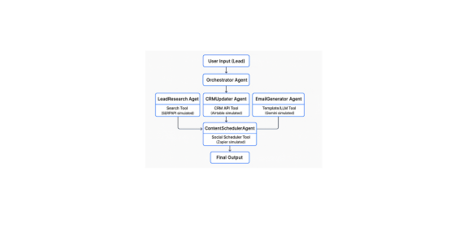

Tab 2

### Agents
| Agent | Role | Tools |
|-------|-------|-------|
| **LeadResearchAgent** | Fetches basic company info | Search Tool (SERPAPI simulated) |
| **CRMUpdaterAgent** | Updates Airtable-like CRM | CRM API Tool (simulated) |
| **EmailGeneratorAgent** | Generates personalized follow-up email | Gemini-style LLM (simulated) |
| **ContentSchedulerAgent** | Schedules marketing posts | Scheduler Webhook Tool (simulated) |
| **Orchestrator** | Coordinates all agents | Executes pipeline sequentially |

---

## Tech Stack
- **Python**
- **Multi-Agent Architecture**
- **Search, CRM, and Scheduler Tools** (simulated for Kaggle safety)
- **Gemini-compatible Email Generator**
- **Kaggle Notebook for development**
- **GitHub for version control**

This design is deployment-ready for:

- **Vertex AI Agent Engine**
- **Google Cloud Run**
- **FastAPI microservice**

---

## Features
✔ End-to-end automated workflow
✔ Modular agent design
✔ Safe simulated API tools
✔ Clear separation between agents and tools
✔ Simple orchestrator pipeline
✔ Ready for real-world API integration
✔ Perfect for portfolio, client demos, or expansion into SaaS

---

## Notebook
The Kaggle Notebook contains:

- Full implementation of the 4 agents
- Tool definitions (simulated)
- Orchestrator pipeline
- Demo execution (`run_full_pipeline("Acme Corp")`)
- Documentation & Markdown

---

## Demo Output Example
When running:

```python
run_full_pipeline("Acme Corp")

Tab 3
The system returns:
- Lead profile
- CRM update status
- Generated follow-up email
- Scheduled post status
All without any manual input.

ADK Concepts Demonstrated
This project fulfills the ADK-based agent design used in the Kaggle x Google Intensive:
- Multi-agent system design
- Tool-based interactions
- Context passing
- Sequential orchestration
- Model-driven generation (Gemini simulated)
- Observability through logs & fallbacks

Future Improvements
With more time, the system could include:
- Real Gemini Pro integration
- Live SERPAPI, Airtable, Zapier connections
- Long-term memory for lead history
- Web UI dashboard (Next.js or Streamlit)
- Deployment on Cloud Run / Agent Engine
- A2A protocol for deeper agent collaboration
- Analytics and reporting engine

Author
Leah Oduor
“Leah The Digital VA”

